Machine Learning   
using Python

**Predict preferred Keyphrase**

Author: Raj Arora

Document Date: 22/6/2021

1st Revision:

2nd Revision:

**Predicting Preferred keyphrase**

**Y:** Preferred keyphrase

**X variables:**

1. Keyword:
2. Clicks:
3. Impressions
4. AvgCPC
5. CTR
6. Datadt

# Predicting Preferred Keyphrase

**Understanding the concept:**

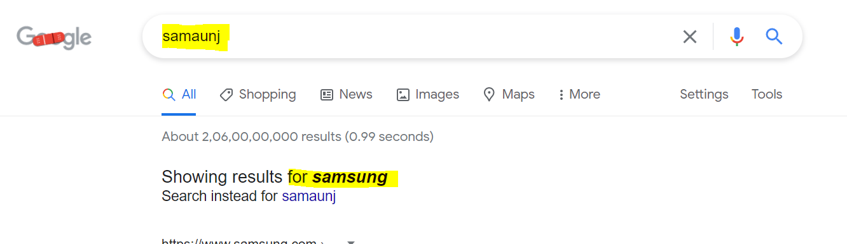

The search term: **samaunj** is called keyword

The preferred keyphrase: **samsung** Google’s suggestion against the search term.

# Project Plan

**Objective:**

**Determine Y variable** (Preferred keyphrase)

**Input variables:**

1. Keyword:
2. Clicks:
3. Impressions
4. AvgCPC
5. CTR
6. Datadt

Search google for the definition of above fields.

Possible steps:

1. Establish correlation among fields
2. Determine impact of the input variable on preferred keyphrase
3. Data streamlining (Possibly Log10)
4. Train the model
5. Test the model
6. Compile model file
7. Put it into the production env.
8. Build an interface where a csv can be uploaded
9. Perform prediction.

**Possible tools:**

1. Visual Studio
2. Visual Studio Code
3. PowerBI
4. Flask